**Research Skills: Text Mining**

**Downloading, Installing, and Launching Jupyter Notebook**

The recommended way to install Jupyter Notebook is by installing the Anaconda software package. This installs several dependencies and additional packages that will make sure everything runs smoothly and provides all the tools that you will need for successful completion of the course.

To download Anaconda, go to <https://www.continuum.io/downloads> and select your operating system. We’ll use the **Python** **3.5** version. Depending on the version of your operating system, you’ll need either the 32- or 64-bit installer – most likely the 64 bit. For Mac users, we recommend using the Graphical installer.

Once downloaded (this may take several minutes), simply follow the instructions in the Installer. From here on, the procedures for Windows and OS X start to diverge a bit.

**Windows**

If the installation was successful, you should now see a folder called ‘Anaconda3 (64-bit)’ in your Start menu. From this folder, you can click the shortcut ‘Jupyter Notebook’ (see screenshot). This opens a command window, which in turn will open a tab in your default browser. This is the Jupyter Notebook. You’re ready to go!

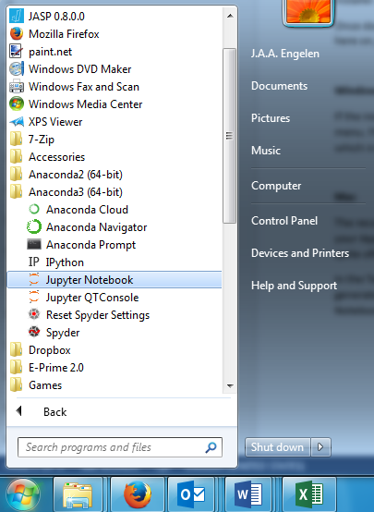

**Mac**

The recommended way to open Jupyter Notebook is to use the Terminal. You can find the Terminal in your Applications folder, in the subfolder ‘Utilities’ (see screenshot 1). Because we will use the Terminal quite often, it is recommended that you add it to your Dock permanently.

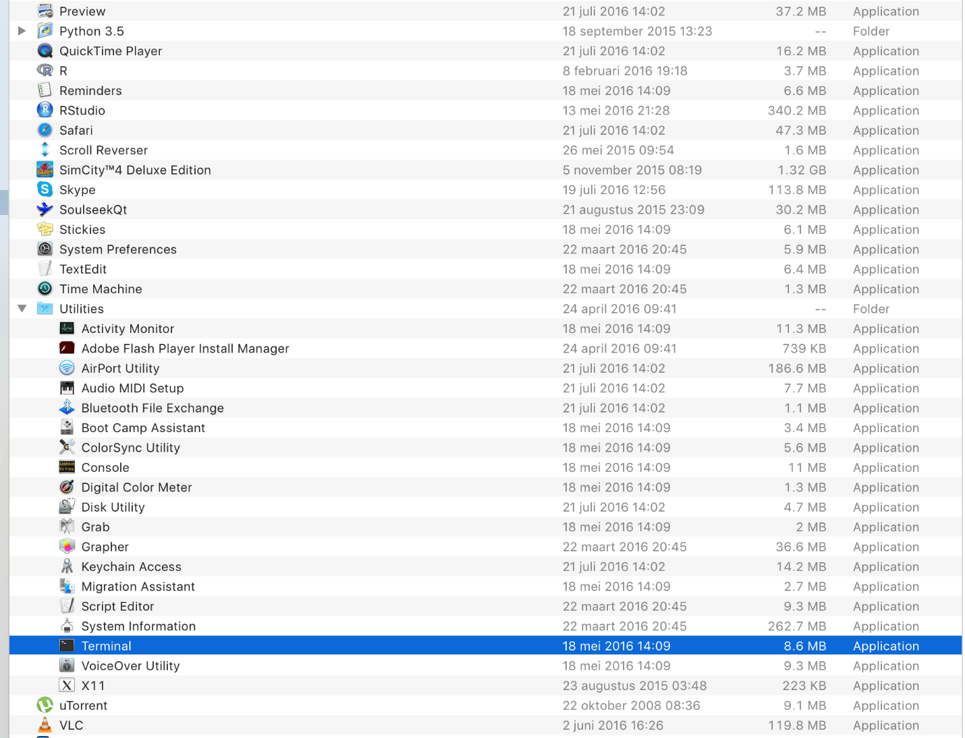

Screenshot 1: Locating the Terminal

In the Terminal, type ‘jupyter notebook’ (all lowercase) and press Enter (see screenshot). That should generate a few lines of output, after which a tab in your browser will open, showing the Jupyter Notebook. You’re ready to go!

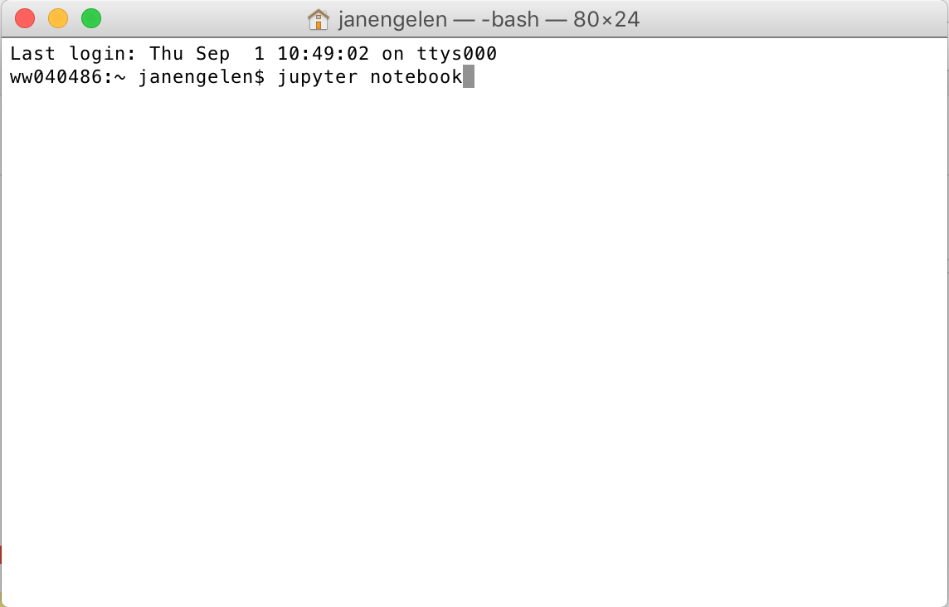

Screenshot 2: Launching Jupyter from the Terminal

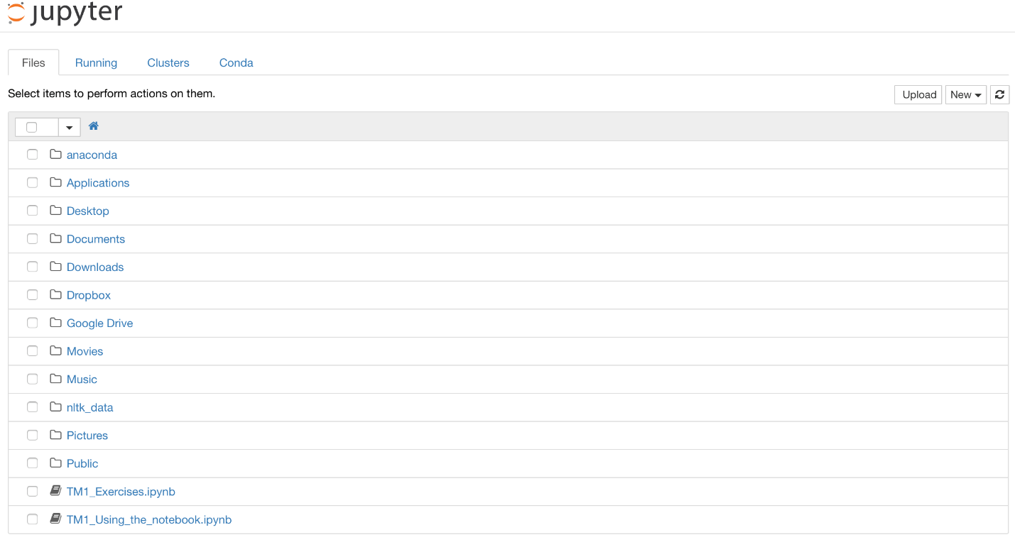

Figure 3 The Jupyter notebook as it should appear in your browser

**Opening the notebooks**

In *Blackboard > Course Documents > Jupyter Notebooks*, you should see two files, named ‘TM1_Using_the_notebook.ipynb’ and ‘TM1_Exercises.ipynb’, respectively. Download these files and save them in a convenient folder, for instance the one that you use for your other coursework.

Note: you cannot open these files directly by double-clicking on them. Rather, you should open them from the file browser in the Jupyter Notebook application. Simply locate the appropriate folder from there and click on the filename once to open it.

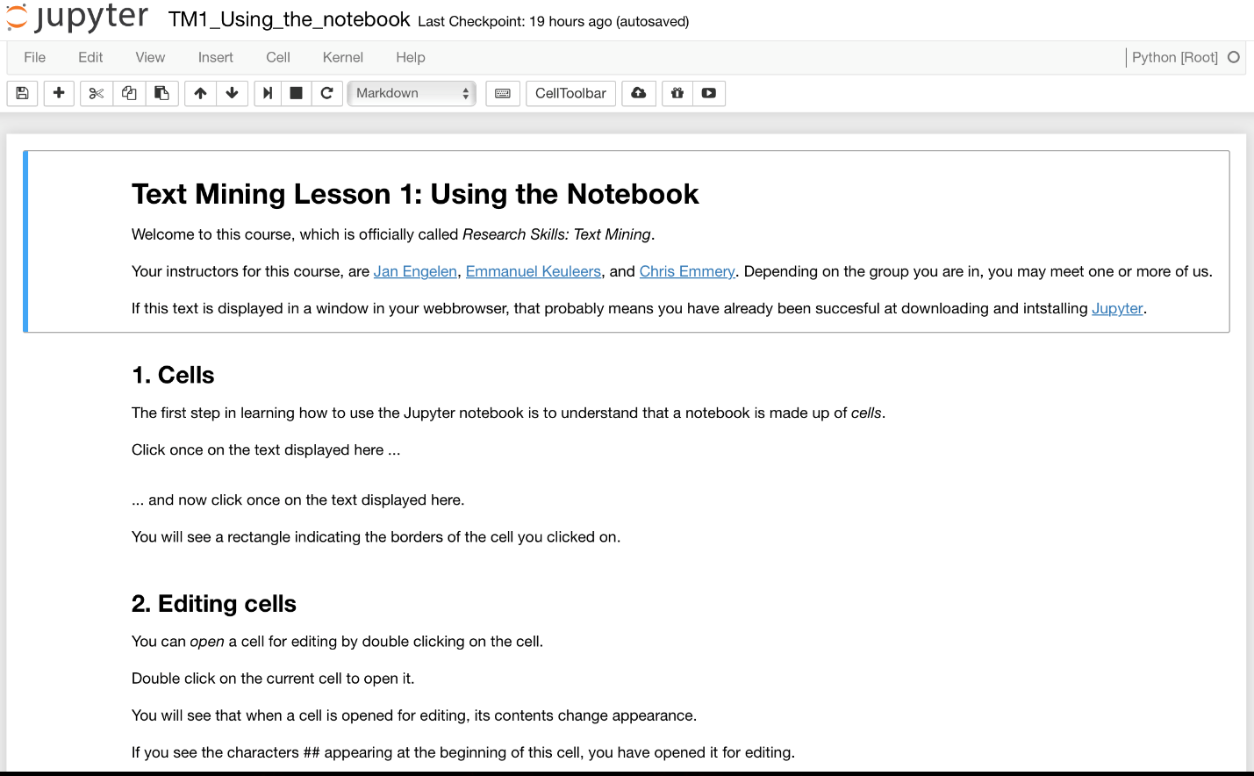

Figure 4 What you should see when opening TM1_Using_the_notebook.ipynb

The notebook ‘**TM1_Using_the_notebook.ipynb**’ is the one Emmanuel worked through during class. It illustrates the working of cells, which can contain code or Markdown, and other basic operations of Jupyter. It is highly recommended that you go through every step of this tutorial. Even if you didn’t attend class, it should be self-explanatory enough to familiarize you with Jupyter.

The notebook ‘**TM1_Exercises.ipynb**’ is the one that contains the exercises that constitute the first assignment, which count toward 10% of your grade.

Follow the instructions in the notebook. The first few exercises are relatively easy and should not cost you much time; the last few exercises are quite challenging and will require you to look up information in the documentation that is provided.

Please upload the notebook with your email address appended to the filename (e.g., ‘TM1_Exercises.ipynb_A.A.Student@uvt.nl’) to Blackboard before **Monday, September 5, 23.59h** (an upload link will be provided).